2019-07-23 Announcement

Interoperability Standards Advisory (ISA) – Open for Review and Comment
The Interoperability Standards Advisory (ISA) annual review and comment period is now open! The ISA is an interactive catalog of standards and implementation specifications supporting interoperability in healthcare, and stakeholder input is crucial to ensure it contains the latest standards/specifications and most accurate industry information. Share your thoughts by Monday, September 23, 2019 at 11:59 pm ET, at which point ONC will begin to finalize the ISA for the 2020 Reference Edition, to be published in December.

The following comments are submitted by Quest Diagnostics:
Thank you for the opportunity to comment on the ISA.
Please change all references to ‘lab’ to ‘laboratory’ throughout the ISA.

ONC Standards
https://www.healthit.gov/isa/onc-standards

API Resource Collection in Health (ARCH)
https://www.healthit.gov/isa/api-resource-collection-health-arch
Text:
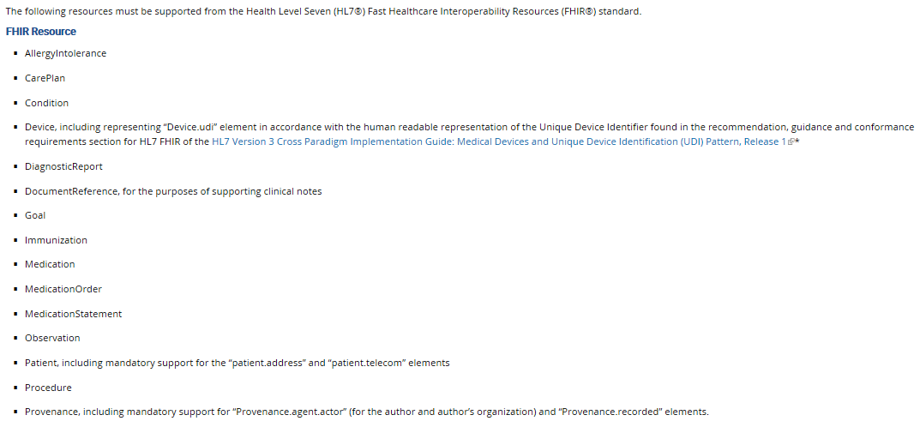
QD Comment:
The ARCH indicates the FHIR DocumentReference resource for Clinical Notes referenced in USCDI. If Laboratory Report Narrative and/or Pathology Report Narrative are included in the USCDI as additional clinical note types, we suggest the FHIR Resource used should be the DiagnosticReport if the intent is to include the actual content contained in the laboratory or pathology report, vs. referring to the report(s) using the FHIR DocumentReference resource (i.e. referring to a PDF, C-CDA, etc.)

We suggest the FHIR release supported should be left to trading partners vs. citing a specific FHIR release in the ISA.

We recommend that patient laboratory results only be rendered to the patient from their ordering/attending provider as their primary health care provider.

U.S. Core Data for Interoperability (USCDI)
https://www.healthit.gov/isa/us-core-data-interoperability-uscdi
Text:
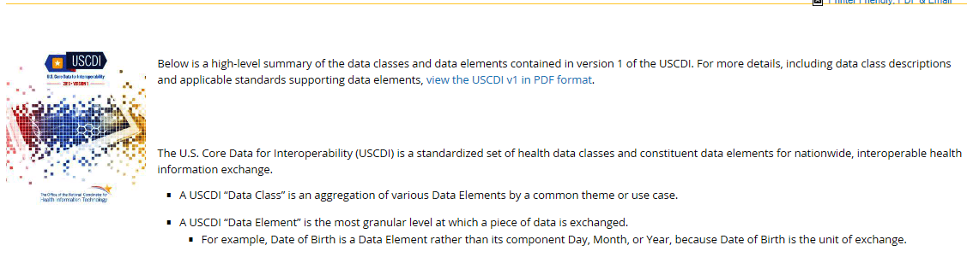

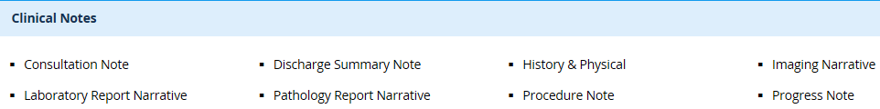

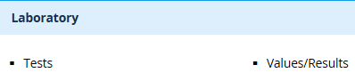
QD Comment:
The ARCH indicates the FHIR DocumentReference resource for Clinical Notes referenced in USCDI. If Laboratory Report Narrative and/or Pathology Report Narrative are included in the USCDI as additional clinical note types, we suggest the FHIR Resource used should be the DiagnosticReport if the intent is to include the actual content contained in the laboratory or pathology report, vs. referring to the report(s) using the FHIR DocumentReference resource (i.e. referring to a PDF, C-CDA, etc.)

We recommend that patient laboratory results only be rendered to the patient from their ordering/attending provider as their primary health care provider.

Section I: Vocabulary/Code Set/Terminology Standards and Implementation Specifications

Representing Laboratory Tests
https://www.healthit.gov/isa/representing-laboratory-tests

2020
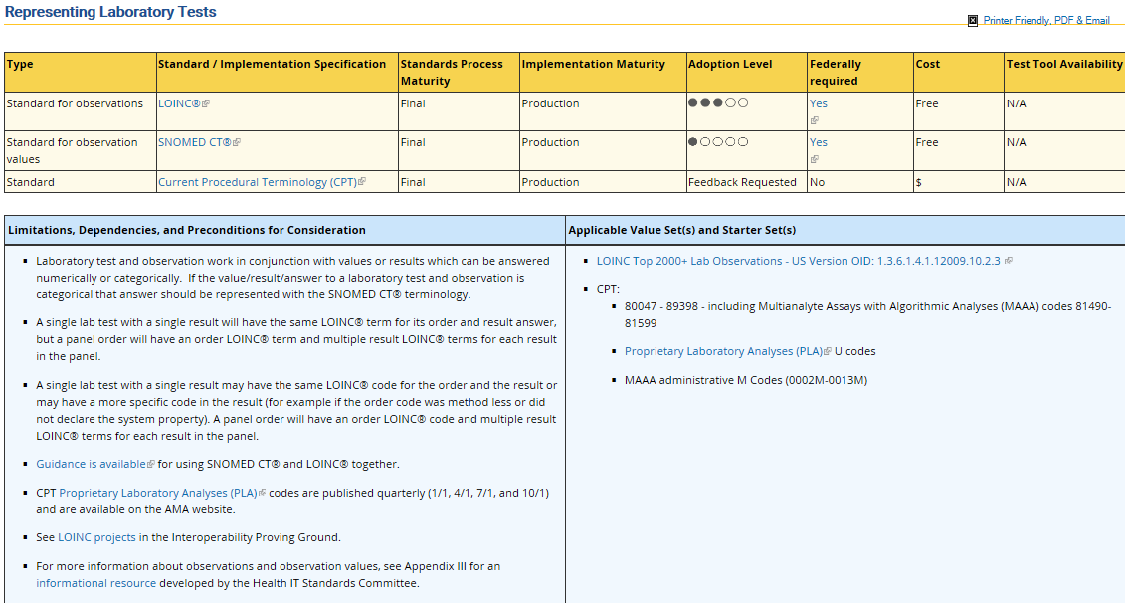
QD Comment:
- Please change ‘lab’ to ‘laboratory’ in Limitations, Dependencies , and Preconditions for Consideration section
- Please add a bullet: LOINC code availability is contingent on assignment by Regenstrief.
- We suggest you remove the 2nd bullet in the “Limitations lll” section; it is replaced by the (current) 3rd bullet
- In the 2nd sentence of (current) 3rd bullet, please change “will” to “may”.
- We are aware that some EHR systems assign LOINC or SNOMED CT codes if not provided by the sending laboratory; these mappings should be approved in advance by the Laboratory sending the result. We suggest ONC add an EHR certification question to ascertain if the EHR system is assigning LOINC or SNOMED CT codes without the sending laboratory’s concurrence, e.g. are you consulting with the sending laboratory re: the assignment of LOINC and SNOMED CT codes.
- Some EHR systems want a 1-to-1 SNOMED CT mapping to each laboratory result, but this not always the case, especially for microbiology. For example, e-coli and Group A Strep (GAS)/Strep pyogenes (STPY) multiple results can have a single SNOMED CT mapping (many results to one SNOMED CT)
- SNOMED CT expertise can be scarce and expensive from resource perspective; SNOMED CT is a very complicated terminology and may be beyond the expertise of a laboratory technologist.
- There is a low adoption of SNOMED CT, which is due to multiple issues. For example, managing the negation aspect, e.g. “no e-coli” could unintentionally be interpreted as “e-coli” if the negation is not interpreted correctly. We suggest ONC work with industry to provide guidance on these issues.
- We strongly recommend that CPT codes not be added to the ISA in this section “Representing Laboratory Tests” for lab tests orders or results; CPT codes are not specific enough to represent laboratory tests and are typically used only related to billing for laboratory tests. Please clarify if CPT is only intended for billing purposes.

Topic: Representing Patient Sex (At Birth)
https://www.healthit.gov/isa/representing-patient-sex-birth

2020
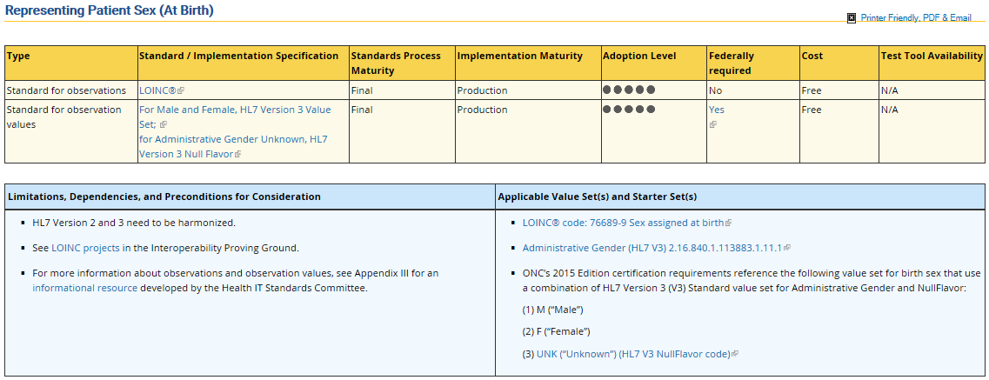
QD Comment:
Since several states permit residents to legally change their birth sex, and are re-defining the value set(s), we suggest ONC change the Topic title to “Representing Sex assigned at birth” to match the LOINC code in the Value Set and to clarify this is intended to report the biological/physiological sex. Some laboratory result reference ranges are dependent on the accuracy of this data.

For example of emerging potentially conflicting state requirements:
- New Jersey: https://www.nbcnews.com/feature/nbc-out/n-j-become-fourth-state-gender-neutral-birth-certificate-option-n964601
- Oregon: https://www.nbcnews.com/feature/nbc-out/judge-grants-oregon-resident-right-be-genderless-n736971
  - “Agender is defined as the absence of gender. Not to be confused with transgender or genderqueer, agender people typically describe feeling that they have no gender identity whatsoever. While sex refers to biological features such as chromosomes, genitalia and hormones, gender is the expression of identity as male, female or somewhere in between. But agender people are not drawn to male or female identity — or any point along the spectrum.”

While the adoption level may be accurate for capturing this data since it is an EHR certification requirement, as a large commercial laboratory, we can assert we are not seeing this data being reported from EHR systems, and all laboratories may not be ready to accept Sex assigned at Birth as an observation (V2 OBX) because they are currently supporting only HL7 V2 “Administrative Sex”. Many EHR systems are still using only V2 values in electronic transactions; suggest change Adoption Level for observations and observation values to 3 bullets.

Topic: Representing Units of Measure (For Use with Numerical References and Values)
https://www.healthit.gov/isa/representing-units-measure-use-numerical-references-and-values

2020
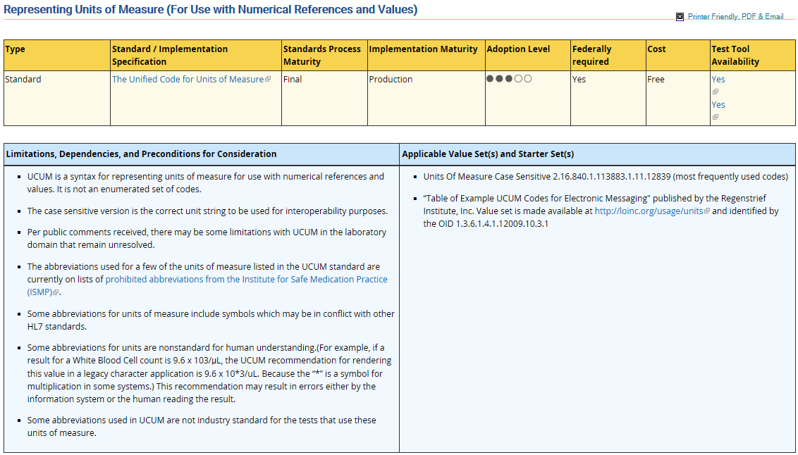
QD Comment:
You have indicated UCUM is Federally required; please provide the hyperlink to the applicable regulation as you have in other sections of the ISA.

Section II: Content/Structure Standards and Implementation Specifications

Support the Transmission of a Laboratory’s Directory of Services to Provider’s Health IT or EHR System
https://www.healthit.gov/isa/support-transmission-a-laboratorys-directory-services-providers-health-it-or-ehr-system

2020
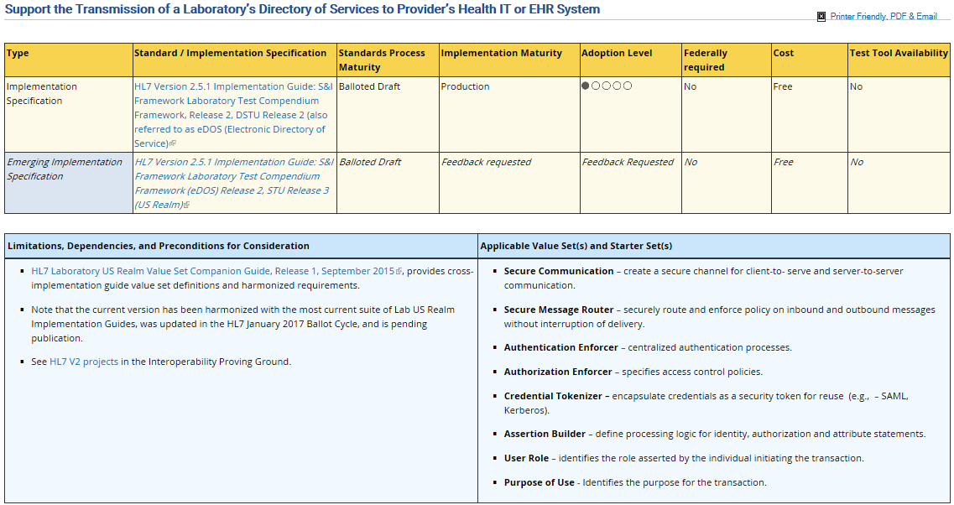
QD Comment:
In response to your request for feedback re: the “Emerging Implementation Specification,” we support Release 2, STU Release 3 published in 2018 which has been updated based on STU comments, and harmonized with other 2018 Laboratory Implementation Guides (LRI, LOI).
It may be premature to include in the ISA, unless as “In Development” status, but there is another “Emerging Implementation Specification” project at HL7, developing resources to express the V2 eDOS content in FHIR resources, referred to as the Order Catalog Interface. It was balloted in 2018 and has been tested in several FHIR connectathons.
Please update the text below in "Limitations, Dependencies, and Preconditions for Consideration"
From:
- HL7 Laboratory US Realm Value Set Companion Guide, Release 1, September 2015, provides cross-implementation guide value set definitions and harmonized requirements.
To (updated text and hyperlink):
- HL7 Version 2 Implementation Guide: Laboratory Value Set Companion Guide Release 1, STU Release 3 - US Realm, June 2018 which is posted at: http://www.hl7.org/documentcenter/public/standards/dstu/V2_IG_VALUESETS_R1_STU3_2018JUN.zip

From:
- Note that the current version has been harmonized with the most current suite of Lab US Realm Implementation Guides, was updated in the HL7 January 2017 Ballot Cycle, and is pending publication
To (updated text):
- Note that the Emerging Implementation Specification has been harmonized with the most current suite of Lab US Realm Implementation Guides, published by HL7 in June 2018.

Identify Linkages Between Vendor IVD Test Results and Standard Codes
https://www.healthit.gov/isa/identify-linkages-between-vendor-ivd-test-results-and-standard-codes

2020
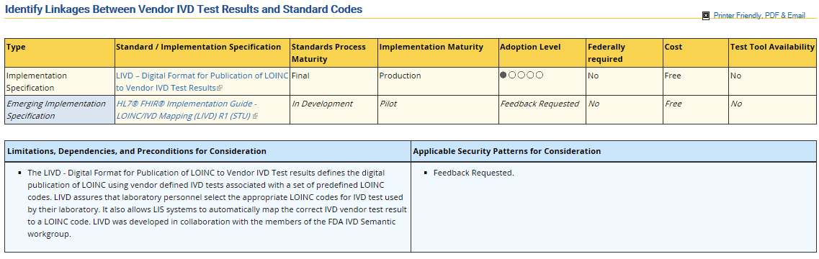
QD Comment:
Please add comment to “Limitations, Dependencies, and Preconditions for Consideration”:
- Note that the LIVD Implementation Specification (LIVD – Digital Format for Publication of LOINC to Vendor IVD Test Results) has not been vetted through a Voluntary Consensus Standards Body (VCSB) as defined in OMB Circular A-119.

Please spell out acronyms at least once on this page:
- in vitro diagnostic (IVD)
- LOINC to IVD ( LIVD)

Ordering Labs for a Patient
https://www.healthit.gov/isa/ordering-labs-a-patient

2020
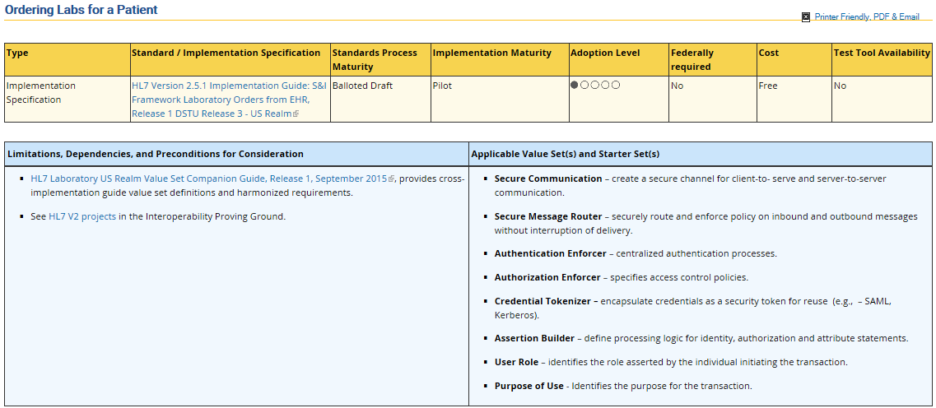
QD Comment:
HL7 published an update to the LOI Implementation Guide (IG) and Value Set Companion Guide June 20, 2018, please update to reflect the latest publications:

- “HL7 Version 2.5.1 Implementation Guide: Laboratory Orders from EHR (LOI) Release 1, STU Release 3 - US Realm”
Link to specification = http://www.hl7.org/documentcenter/public/standards/dstu/V251_IG_LABORDERS_R1_STU_R3_2018JUN.pdf

Please update the Value Set IG which specifies the vocabulary used in the IGs and is ‘companion’ to the LOI IG:
“HL7 Version 2 Implementation Guide: Laboratory Value Set Companion Guide Release 1, STU Release 3 - US Realm HL7 Standard for Trial Use”
Link to specification = http://www.hl7.org/documentcenter/public/standards/dstu/V2_IG_VALUESETS_R1_STU3_2018JUN.zip

Receive Electronic Laboratory Test Results
https://www.healthit.gov/isa/receive-electronic-laboratory-test-results

2020
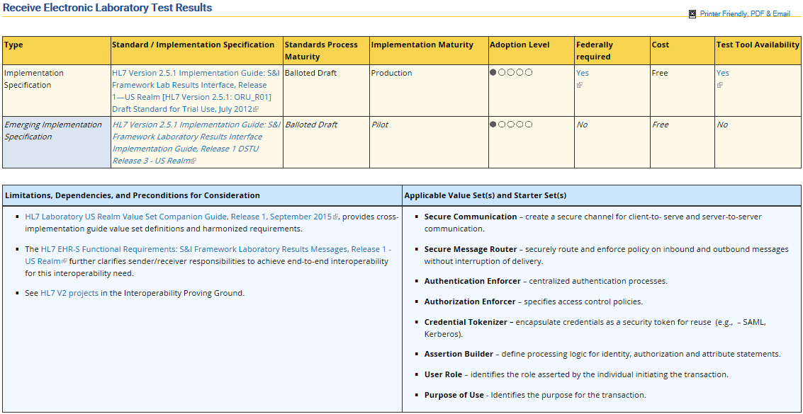
QD Comment:
Emerging Implementation Specification, correct the title to: “HL7 Version 2.5.1 Implementation Guide: Lab Results Interface (LRI) Release 1, STU Release 3 - US Realm HL7 Standard for Trial Use”

In Limitations, Dependencies…, please update the Value Set IG which specifies the vocabulary used in the IGs and is ‘companion’ to the LOI IG:
Link to specification = http://www.hl7.org/documentcenter/public/standards/dstu/V2_IG_VALUESETS_R1_STU3_2018JUN.zip

Electronic Transmission of Reportable Lab Results to Public Health Agencies
https://www.healthit.gov/isa/electronic-transmission-reportable-lab-results-public-health-agencies

2020
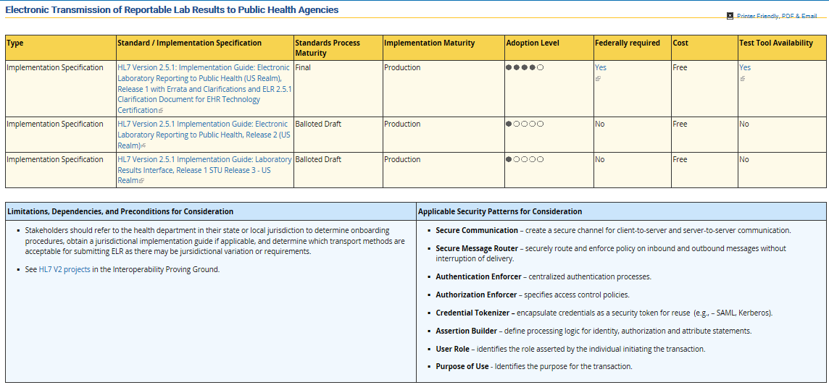
QD Comment:
Since the 3rd implementation specification is a different title, suggest you add a bullet explaining the content in the first two Electronic Laboratory Reporting (ELR) implementation specifications is now handled as a profile in the third listing, e.g. the Laboratory Results Interface (LRI) implementation specification, using the “LRI_PH_COMPONENT – ID: 2.16.840.1.113883.9.195.3.5” Result Profile Component.

In Limitations, Dependencies…, please add the Value Set IG which specifies the vocabulary used in the Laboratory Results Interface IG and is ‘companion’ to the LRI IG cited as 3rd standard/IG:
Link to specification = http://www.hl7.org/documentcenter/public/standards/dstu/V2_IG_VALUESETS_R1_STU3_2018JUN.zip

Please change ‘Lab’ to ‘Laboratory’ in the topic title, e.g. …Reportable Laboratory Results…

Public Health Reporting/Reporting Cancer Cases to Public Health Agencies
https://www.healthit.gov/isa/reporting-cancer-cases-public-health-agencies

2020
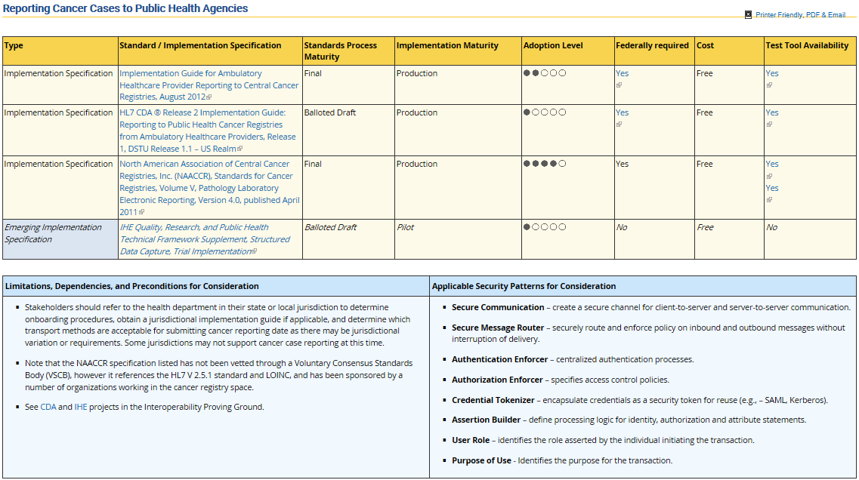
QD Comment:
In the 2020 ISA update, the NAACCR implementation specification has been changed to “Federally required” and “Yes”. Please add a hyperlink indiciating the source of federal requirement which has apparently changed since the 2019 publication of the ISA (see 2019 screen print below).

2019 (referenced in 2020 comment)
Text:
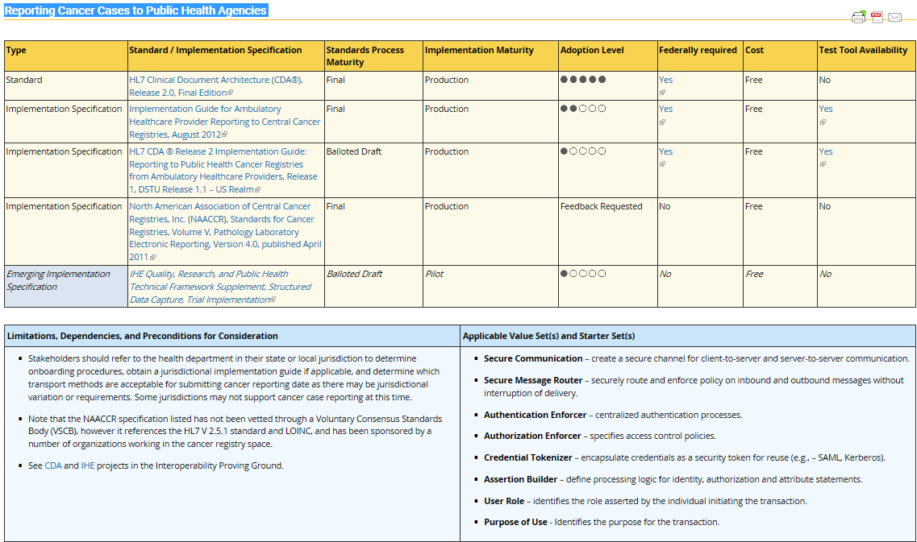

Questions and Requests for Stakeholder Feedback
https://www.healthit.gov/isa/questions-and-requests-stakeholder-feedback

Updated questions for the 2019 Review and Comment Period
As with the previous iterations of the Interoperability Standards Advisory (ISA), posing questions has served as a valuable way to prompt continued dialogue with stakeholders for continuous improvement of the ISA. In addition to the questions and requests for feedback below, stakeholders are encouraged to review content within the sections and specific Interoperability Needs to provide feedback, or submit requests for new Interoperability Needs, as necessary.
Historical questions and requests for stakeholder feedback have been moved for viewing history, but comments on and responses to these questions remain on this page, or may be included in comment letters received posted as comments elsewhere on the ISA.

19-1
Text:
19-1: In what ways has the ISA been useful for you/your organization as a resource? ONC seeks to better understand how the ISA is being used, by whom, and the type of support it may be providing for implementers and policy-makers.

QD Comment:
We review and comment annually for laboratory impacts.

19-2
Text:
19-2: Are there additional features or functionality ONC could make to the ISA website that would enhance the user experience?

QD Comment:
Functioning well as is. If possible, it would be helpful to have a .pdf version of the draft changes in addition to the online view currently provided for the review process

19-3
Text:
19-3: The adoption level, along with other informative characteristics about standards/implementation specifications, was introduced to the ISA in August, 2015, and currently represents ONC’s “best guess” at current adoption based on a number of factors. Is the adoption level characteristic as it stands valuable information for stakeholders, or should it be retired or replaced with other information?

QD Comment:
We suggest you retire the adoption level since, as you say, it is a “best guess” and not really based on quantifiable data. Additionally you may rate an item at a high level of adoption because it is required for EHR certification, but it is not being electronically exchanged so it is not contributing to interoperability at a high level (for example, gender identity.)

Appendix I – Sources of Security Standards and Security Patterns
https://www.healthit.gov/isa/appendix-i-sources-security-standards-and-security-patterns
Text:
4th bullet: ASTM

QD Comment:
This hyperlink returns error: 404: Page Not Found
Suggest you remove this entry since it does not indicate a specific ASTM standard with functional hyperlink, or correct the hyperlink.

Appendix II - Models and Profiles
https://www.healthit.gov/isa/appendix-ii-models-and-profiles

HL7 Standards - Section 1: Primary Standards
Text:
HL7 Standards - Section 1: Primary Standards
SECTION 1 Primary standards are the most popular standards integral for system integrations, and interoperability. Our most frequently used and in-demand standards are in this category. (This section also includes the Version 2 and Version 3 solution sets, which encompass all standards relative to that version. Individual V2 and V3 standards are sold independently in the corresponding categories.)

QD Comment:
Most HL7 standards are licensed at no cost. Rather than stating “…standards are sold independently…” we suggest you refer the reader to HL7's Standards Licensed At No Cost policy statement at: http://www.hl7.org/implement/standards/nocost.cfm

IHE Profiles
- IHE Profiles describe specific solutions to integration problems. A profile documents how standards will be used by each system's Actors to cooperate to address the problem.
Text: (example)
Laboratory Testing Workflow

This profile is part of the Pathology and Laboratory Medicine (PaLM) domain, which merged the former AP and LAB domains since 2016, January 4th.
Laboratory Testing Workflow (LTW) integrates the ordering, scheduling, processing, and result reporting activities associated with in vitro diagnostic tests performed by clinical laboratories in healthcare institutions.

QD Comment:
In order to avoid potentially conflicting requirements, please add a general statement (perhaps as an introductory section to Appendix II) that standards, implementation guides (IGs), profiles, etc. developed/sponsored by the Office of National Coordinator (ONC) or previously cited by a federal agency in a Final Rule supersede other standards, (IGs), profiles, etc. included in the ISA.

For example, the ONC Standards & Interoperability Framework sponsored a suite of HL7 V2.5.1 laboratory implementation guides (LOI, LRI and associated value set companion guide) which may conflict with the IHE Laboratory Testing Workflow based on HL7 V2.5 and V2.5.1.

http://www.hl7.org/fhir/diagnosticreport.html
http://www.hl7.org/fhir/documentreference.html
http://www.hl7.org/fhir/diagnosticreport.html
http://www.hl7.org/fhir/documentreference.html
https://www.whitehouse.gov/omb/circulars/ and https://www.whitehouse.gov/sites/whitehouse.gov/files/omb/circulars/A119/revised_circular_a-119_as_of_1_22.pdf

