CMS Data Element Library HITWG Comments on the ONC 2019 Interoperability Standards Advisory (ISA)
August 28, 2019
The Centers for Medicare and Medicaid (CMS) Data Element Library (DEL), Health Information Technology Workgroup (HITWG) evaluated the 2019 Interoperability Standards Advisory and offer the following comments based on an analysis against the data classes and related health IT vocabulary codes for the federally required post-acute care (PAC) assessment instruments.
Section I – Vocabulary/Code Sets/Terminology Standards and Implementation Specifications
- Representing Functional Status and/or Disability
  - Recommendation Applicable Value Sets:
- The CMS DEL HITWG recommends that the 2019 ISA be updated to list the CMS functional status data elements (and related LOINC and SNOMED representations) that are used across multiple settings for collection of Functional Abilities and Goals (Self-care and Mobility items found in section GG of PAC assessments).
  - These data elements have been designed and tested for use across multiple care settings and are utilized in clinical quality measures.
  - Use of the functional status data elements are not limited to post-acute care (PAC) and can be utilized by any setting. The CMS proposed rule published on March 4, 2019 recommended expansion of the CMS PAC assessment data elements to other settings. Industry responses were supportive.
- We recommend two updates to the value sets currently referenced:
  - Identify the functional status data elements that are standardized across multiple settings and assessment instruments (Self-care and Mobility items found in section GG of PAC assessments).
  - Update the version of MDS referenced in the ISA to the most current version – MDS 1.17.1. As the instruments are updated, recommend updating the versioning and/or including a link to the site where the instruments may be found. Please see Table 1 below.
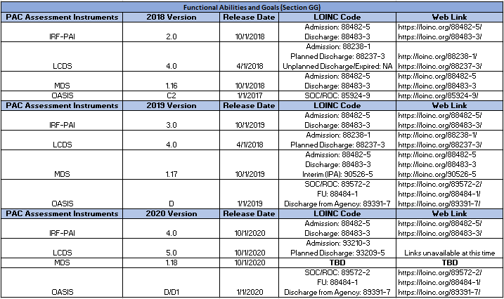
Table 1: CMS Assessment- Functional Abilities and Goals

- We recommend including this link: https://del.cms.gov/DELWeb/pubHome with directions to use the GG items and or download the HIT codes https://del.cms.gov/DELWeb/pubDownloadHitCodesForm in the table for limitations and considerations.
- Recommendation Considerations and Limitations:
  - Under Considerations and Limitations table, we recommend adding a link to the PACIO Workgroup (http://pacioproject.org/). This group is developing FHIR use cases for the exchange of functional status and cognitive status information between healthcare settings.
- Recommendation Representing Clinical/Nursing Assessments
  - The CMS DEL HITWG recommends updating the CMS post-acute care clinical assessments and referencing the CMS DEL for related LOINC and SNOMED codes in the Applicable Value Set(s) and Starter Set(s). See Table 2 below.

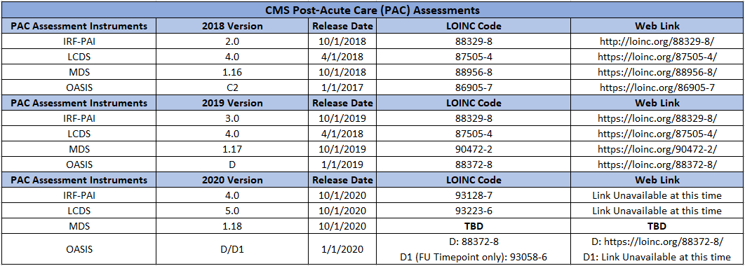
Table 2: CMS Assessment and Related Value Sets
- Recommendation for Preferred Language
  - The CMS DEL HITWG recommends mentioning in the “Limitations, Dependencies, and Preconditions for Consideration” section that CMS has identified Social Determinants of Health items (Race and Ethnicity, health literacy, transportation, preferred language) to be used across PAC Settings. The items will be included in PAC assessments effective in 2020 and associated LOINC codes will be available in LOINC Release 2.67 in December 2019.
- Recommendation for Race and Ethnicity
  - The CMS DEL HITWG recommends mentioning in the “Limitations, Dependencies, and Preconditions for Consideration” section that CMS has identified Race and Ethnicity items to be used across PAC Settings. The items will be included in PAC assessments effective in 2020 and LOINC codes will be available in LOINC release 2.67 in December 2019.
- Recommendation for Social, Psychological, and Behavioral Data:
  - Recommendation: The DEL HITWG recommends that this section reference the following work and incorporate as appropriate:
    - There currently is not an applicable section in ISA related to behavioral data. Please consider adding one and referencing the CMS MDS version 1.17.1 assessment for Behavioral Symptoms.
    - Under section for “Representing Social Connection and Isolation”, consider adding items used in CMS PAC assessments effective in 2020, including Transportation (from the PRAPARE Tool), Race and Ethnicity, Health Literacy, Preferred language, and Social Connection and Isolation (SILS).
- Section II – Content/Structure Standards and Implementation Specifications
- Recommendations for Patient Preferences/Consent:
  - Identify data elements for future expansion of this Section on Patient Preference/Consent to also include a standard for sharing details on preferences of caregivers who consent on a patient’s behalf or representation of their care proxy.
Questions and Requests for Stakeholder Feedback
- 19-3: The adoption level, along with other informative characteristics about standards/implementation specifications, was introduced to the ISA in August, 2015, and currently represents ONC’s “best guess” at current adoption based on a number of factors. Is the adoption level characteristic as it stands valuable information for stakeholders, or should it be retired or replaced with other information?
  - Recommendation: Though mental status is related to a patient’s functional status, consider creating a distinct category that outlines the standards around information exchange for cognitive status. Include standardized, recommended assessment instruments such as BIMS, CAM. See Table 3 below.

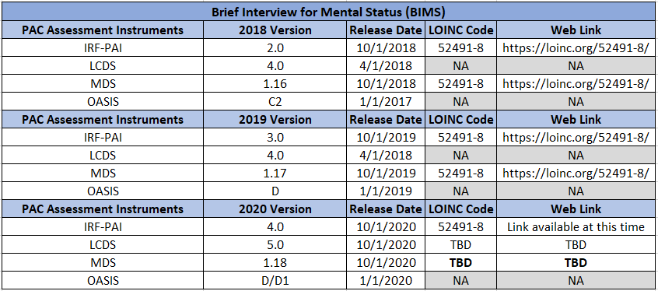

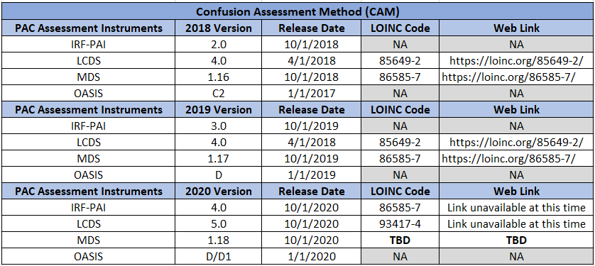
Table 3: CMS Assessment- BIMS and CAM

CMS Proposed Rule. Medicare and Medicaid Programs; Patient Protection and Affordable Care Act; Interoperability and Patient Access for Medicare Advantage Organization and Medicaid Managed Care Plans, State Medicaid Agencies, CHIP Agencies and CHIP Managed Care Entities, Issuers of Qualified Health Plans in the Federally- Facilitated Exchanges and Health Care Providers. March 4, 2019.

