Comments_Exchanging Imaging Documents Within an HIE Domain_DICOM

There are IHE Connectathon testing results for Web-based Image Capture (which uses STOW-RS)

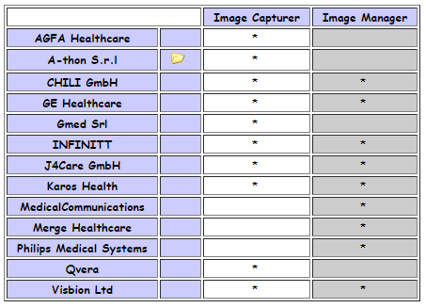

and Web-based Image Access (which uses QIDO-RS and WADO-RS).

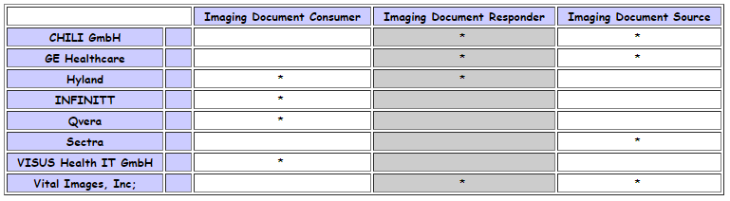

So for DICOMweb, we suggest at least Medium if not High, definitely not Low.

Examples with DICOMweb™ support
- Agfa
  - Main page: https://global.agfahealthcare.com/main/miscellaneous/interoperability/dicom_connectivity/
  - Conformance statement mentioning DICOMweb: http://www.agfahealthcare.com/global/en/he/library/libraryopen?ID=53821200
- Sectra
  - Main page: https://medical.sectra.com/knowledge-center/conformance-statements/
  - Conformance statement mentioning QIDO/WADO: https://sectramedical.blob.core.windows.net/uploads/2019/03/pacs-dicom-conformance-statement-21.1.pdf
- GE
  - Main page: https://www.gehealthcare.com/products/interoperability/dicom
  - Conformance statement mentioning DICOMweb: https://www.gehealthcare.com/-/media/7527e637d6ca478c8f94aca52580e75b.pdf?la=en-us
- Vital
  - Main page: https://www.vitalimages.com/customer-success-support-program/compliance-documents/
  - Conformance statement mentioning DICOMweb: https://www.vitalimages.com/wp-content/uploads/VLC-10295-A-Vitrea-View-7.5-DICOM-Conformance-Statement_.pdf
- Orthanc (open source)
  - Main page: https://www.orthanc-server.com/static.php?page=documentation
  - Page mentioning DICOMweb support: https://docs.google.com/spreadsheets/d/e/2PACX-1vSBEymDKGZgskFEFF6yzge5JovGHPK_FIbEnW5a6SWUbPkX06tkoObUHh6T1XQhgj-HqFd0AWSnVFOv/pubhtml?gid=654036639&single=true
- DCM4CHEE (open source)
  - Main page: https://dcm4chee-arc-cs.readthedocs.io/en/latest/introduction.html
  - Page mentioning QIDO/WADO/STOW: https://dcm4chee-arc-cs.readthedocs.io/en/latest/networking.html

Examples with DICOMweb™ support but not in Conformance statement
- Philips
  - Main page: https://www.usa.philips.com/healthcare/resources/support-documentation
  - Mentions DICOMweb here: https://www.philips.ae/healthcare/product/HCAPP035/dicom-web
- Merge
  - Main page: https://www.merge.com/Support/Resources/DICOM-Conformance-Statements.aspx
  - Mentions DICOMweb AND the latest supplement in DICOMweb on thumbnails: https://www.merge.com/Solutions/Toolkits/Merge-DICOM-Toolkit.aspx
- Intelerad
  - Main page: https://www.intelerad.com/en/resources/regulatory-compliance/
  - Mentions DICOMweb support here: https://www.intelerad.com/en/press-releases/intelerad-launches-cosmosone-living-medical-archive/
- Hyland
  - Main page: https://www.hyland.com/en/healthcare/conformance-and-standards
  - Mentions DICOMweb support here: https://www.hyland.com/en/healthcare/enterprise-imaging/acuo-vendor-neutral-archive

This list is based on initial research and not complete as there are likely many more.

